The process to generate the test document in WORD format from ALM Test Plan:
- After accessing ALM, click on Tools --> Document Generator:
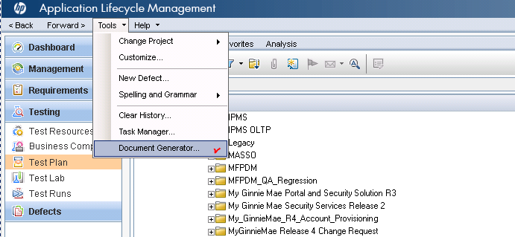
The following screen will pop up:
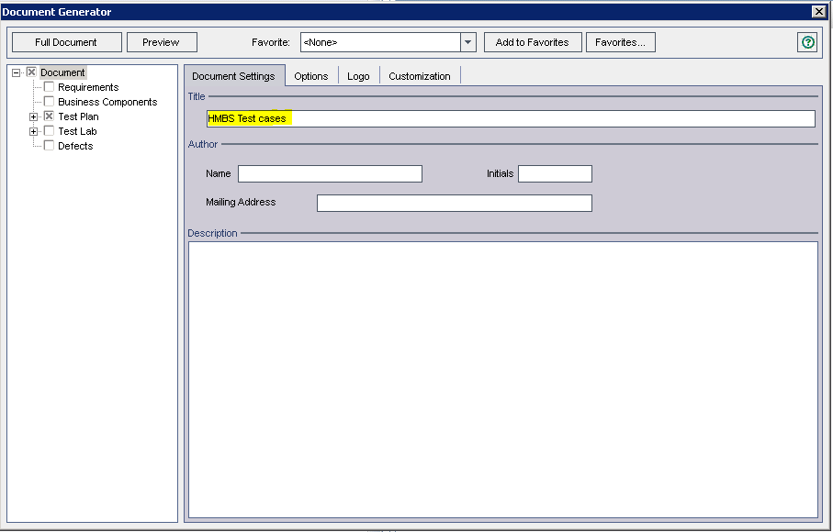

- Enter the name you want to the “Title” row on the “Document Generator” window, which will serve as title page in the test document generated.
- Click on “Test Plan” --> “Subject Tree” --> “Test List” on the left side of the screen and then click on “Customize” under “Design steps” --> “Tabular” (marked as 3) as shown blow.
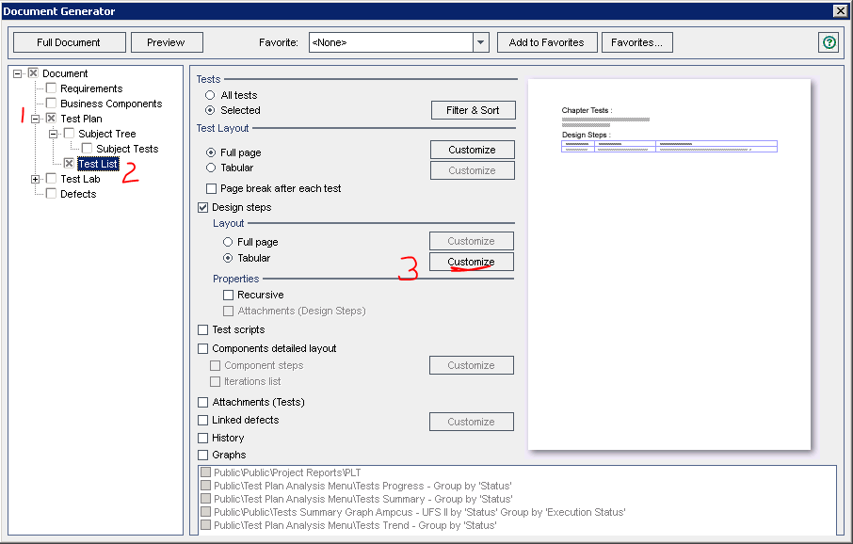

- You will see the “Tabular Layout” window pops up as below which allow you to set up the layout for the testcase. Please make sure that you enter the same value as shown in the screen below:

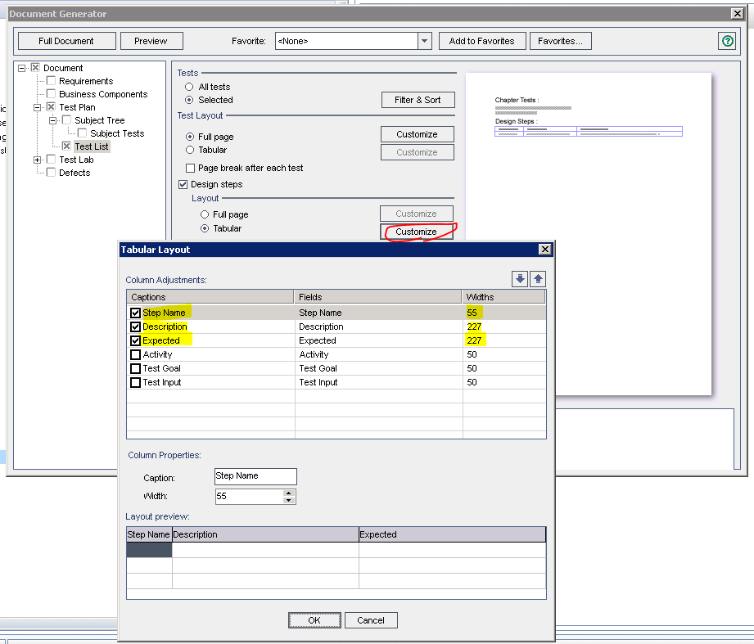
This indicates that you want each of your test cases generated to have only 3 columns: Step Name (width = 55), Description(width = 227), and Expected (width = 227) like below:
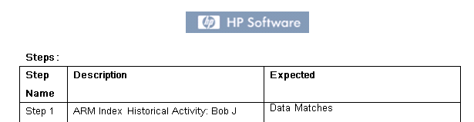

Once it is set up correctly, click “OK” to accept this layout.
- Click on “Filter & Sort” on Tests section as shown on the following screen. This will allow you to select the folder(s) for the test document.
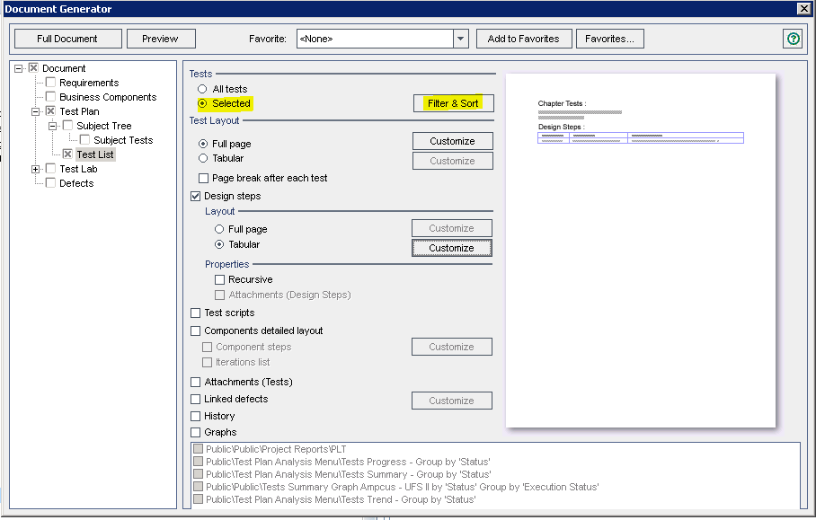
The “Filter Tests” screen will show as following:
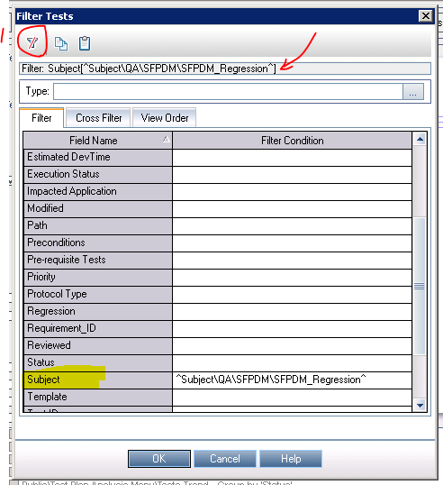

- Click on the clear filter sign (marked as 1 on the screen above) which will clear out the previous subject selected to generate the document. Then, scroll down to “Subject” row (highlighted in yellow) and then click on right space cell. It will pop up like the following screen:
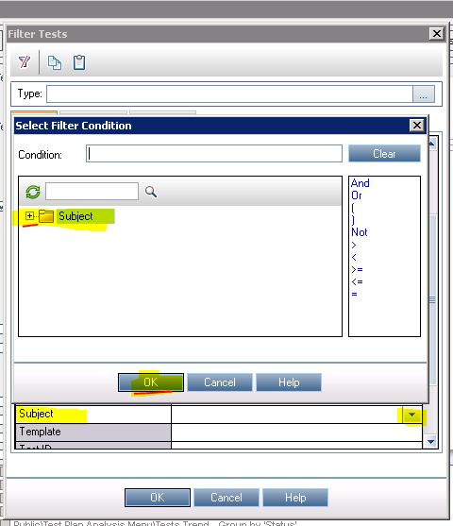

Click on the “+” sign on the Subject to expand and then select the folder you want to add. If you have multiple folders to choose, then you can add the folder you want and then click on “or” on the right between the folders added. Aterward, click OK twice to go back to “Document Generator” window.

- You can click on “Preview” to see if the format is correct. if format is accepted, then you can click on “Full Document”. Enter the file name to save the generated document.

